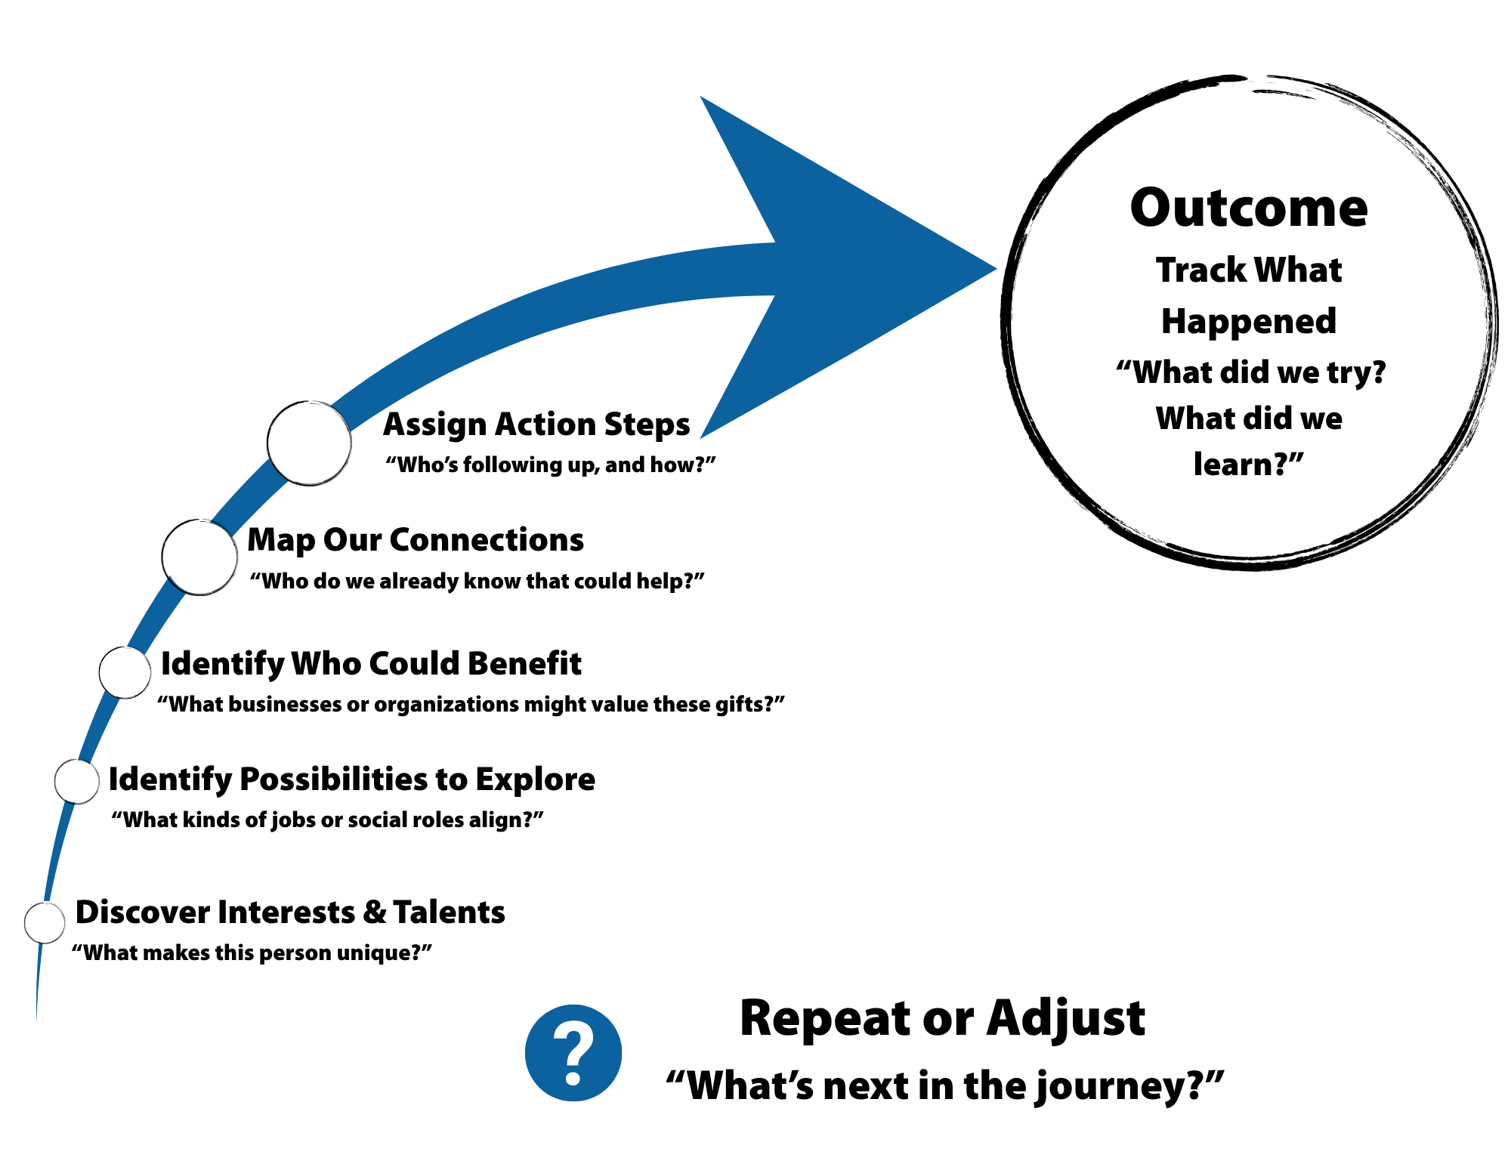
CIE and CLE Workforce & Community Mapping Tool

CIE and CLE Workforce & Community Mapping Tool
Job Seeker/Day Service Participant_______________________

Discover: Identify Unique Interests, Preferences, Talents, & Potential Contributions  (e.g., Individual Discovery or Service Profile) | Identify: CIE Job Goals and/or Social Activity Engagements to Explore (Translating info to opportunities to explore) | Who Can Benefit? Identify Businesses or Organizations That Value These Gifts | Map our Connections: Who do we know? (Identify Business and Community Contacts)? | Assign: Who will Follow-Up? | Action/Outcomes:  What Happened?

